**MORSE CODE**

Internet of things (IoT)

Name: Ahmed Mamnoon

Villa college student ID: S2200763

UWE student ID: 22032649

Introduction

The Micro:bit Morse Code Communicator is a program that enables communication using Morse code signals between two micro:bit devices. It utilizes the micro:bit's radio module, LEDs, and sound capabilities to send and receive Morse code messages.

Features

1. Send Morse code signals using buttons A (dot) and B (dash).

2. Receive Morse code signals wirelessly through the micro:bit's radio module.

3. Decode received Morse code signals to display corresponding characters on the LED.

4. Use predefined Morse code mapping for both letters and numbers.

Requirements

1. Two micro:bit devices (Sender and Receiver).

2. Fully charged batteries for reliable usage.

Installation

1. Flash the Code:

* Connect a micro:bit device to your computer and select it in the editor.
* Click "Download" to flash the code onto the micro:bit.

2. Set Up Devices:

* Flash the code onto both micro:bit devices (Sender and Receiver).
* Make sure both devices are on the same radio group (e.g., group 6) for communication.

1. Press Button A for a Dot:

* Press the A button to send a dot signal.
* The LED will display a dot, and a high-pitched sound will play.
* The dot signal will be transmitted wirelessly to the Receiver.

2. Press Button B for a Dash:

* Press the B button to send a dash signal.
* The LED will display a dash, and a high-pitched sound will play.
* The dash signal will be transmitted wirelessly to the Receiver.

Receiver Micro:bit

1. Displaying Received Morse Code Signals:

* The Receiver micro:bit listens for Morse code signals through the radio module.
* When a dot signal is received, a dot will appear on the LED display.
* When a dash signal is received, a dash will appear on the LED display.

2. Decoding Morse Code to Characters:

* The micro:bit will attempt to decode the received Morse code signals.
* After receiving a signal or waiting for a pause, the micro:bit will display the corresponding character on the LED display.

Here is the international morse code:

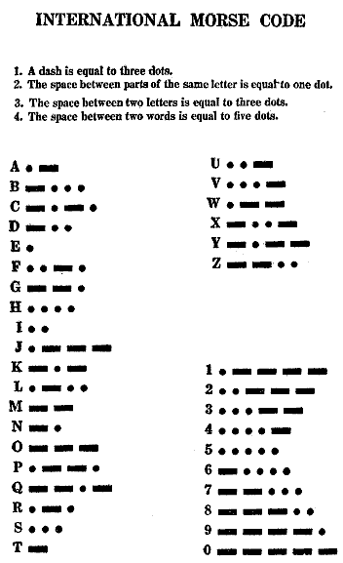

Conclusion

The Micro:bit Morse Code Communicator allows you to send and receive Morse code messages using micro:bit devices. By using buttons to input dots and dashes and listening for radio signals, you can communicate messages in Morse code and decode them on the receiving end.